

危险废物污染环境防治责任制度
Hazardous Waste Pollution Prevention and Control Responsibility System

内部使用
在使用前，请和文档编写人员确认本文档为最新版本。
未经上海暻熠数据科技有限公司、上海暻耀网络技术有限公司书面许可，其它任何机构或个人不可传阅、引用或复制本文件的内容。

Internal use
Before using, check with the documentation writer to make sure this document is the latest version.
Without the written permission of Shanghai Jingyi Data Technology Co., Ltd., Shanghai Jingyao internet Technology Co., Ltd., no other organization or individual is allowed to circulate, quote or copy the content of this document.
文件编号Documents | IP-PJ-EHS-29
版 本Edition | V1.0
文件维护部门File maintenance department | 上海浦江数据中心
会签部门Document Signing department | 上海浦江数据中心
执行范围Scope of execution | 上海浦江数据中心

文件修订记录
Document revision record

版本号  Edition | 版本日期  Date | 修订内容  Revised Content | 修订人员  Revision personnel | 核准员  Approver | 备注  Remarks
V1.0 | 2025-06-25 | 初版发布 | 楚靖岳 | 陆磊

目录 Contents
1 目的Purpose 4
2 适用范围 Scope of application 4
3 规范性引用文件 Reference documents 4
4术语和定义Terms and definitions 4
5 职责Responsibilities 5
5.1 各部门/岗位/业务线Departments/positions/lines of business 5
5.2 EHS管理负责人 EHS officer 5
6程序 Procedures 5
6.1危险废物防治责任制度 Hazardous waste prevention and control responsibility system 5
7 附件Attachments 6

1 目的Purpose
本制度旨在建立上海暻熠数据科技有限公司、上海暻耀网络技术有限公司（以下简称“上海浦江数据中心”）危险废物污染防治责任制度。目标包括确保遵守国家和地方法律法规、国外相关法规、客户要求以及上海浦江数据中心内部要求，确保危险废物污染防治责任管理合规，降低运营EHS风险，并促进持续改进。
This system aims to establish the hazardous waste pollution prevention and control responsibility system of Shanghai Jingyi Data Technology Co., Ltd., Shanghai Jingyao internet Technology Co., Ltd.. (hereinafter referred to as "SHANGHAI Pujiang Data Center"). The objectives include ensuring compliance with national and local laws and regulations, relevant foreign regulations, customer requirements and internal requirements of SHANGHAI PUJIANG Data Center, ensuring compliance with hazardous waste pollution prevention and control responsibility management, reducing operational EHS risks, and promoting continuous improvement.

2 适用范围 Scope of application
适用于上海浦江数据中心，以及所有与EHS有关事项的管理职能部门。
Applicable to SHANGHAI PUJIANG Data Center and all management functions related to EHS.

3 规范性引用文件 Reference documents
《中华人民共和国固体废物污染环境防治法》（2020年修订）
Law of the People's Republic of China on the Prevention and Control of Environmental Pollution by Solid Waste (revised in 2020)
《河北省固体废物污染环境防治条例》（2022年12月1日起施行）
Regulations of Hebei Province on the Prevention and Control of Environmental Pollution by Solid Waste (Effective from December 1, 2022)
《河北省危险废物规范化环境管理评估工作指南》（2023年版）
Guidelines for Standardized Environmental Management Assessment of Hazardous Waste in Hebei Province (2023 edition)
《江苏省固体废物污染环境防治条例》 (2024年修正)
Regulations of Jiangsu Province on the Prevention and Control of Environmental Pollution by Solid Waste (revised in 2024)

4术语和定义Terms and definitions
无
None

5 职责Responsibilities

5.1 各部门/岗位/业务线Departments/positions/lines of business
5.1.1遵守上海浦江数据中心危险废物污染责任制度。
Comply with the hazardous waste pollution responsibility system of SHANGHAI PUJIANG Data Center.

5.2 EHS管理负责人 EHS officer
5.2.1制定、审查并定期更新本程序。
Develop, review and regularly update this procedure.

6程序 Procedures

6.1危险废物防治责任制度 Hazardous waste prevention and control responsibility system
6.1.1上海浦江数据中心遵循环境保护“预防为主，防治结合”的工作方针和“三同时”规定做到生产建设与保护环境同步规划、同步实施、同步发展。
SHANGHAI PUJIANG Data Center follows the work policy of "prevention first, prevention combined" and the "three simultaneities" of environmental protection to achieve synchronous planning, implementation and development of production construction and environmental protection.

6.1.2上海浦江数据中心主要负责人是危险废物污染防治工作的第一负责人，对上海浦江数据中心环境保护工作负全面的领导责任，并引导其稳步向前发展。
The main person in charge of SHANGHAI PUJIANG Data Center is the first person in charge of the prevention and control of hazardous waste pollution, and assumes the overall leadership responsibility for the environmental protection work of SHANGHAI PUJIANG Data Center, and guides its steady development.

6.1.3上海浦江数据中心以主要负责人为首与EHS管理负责人组成危险废物污染防治工作小组，对上海浦江数据中心各项环境保护工作进行决策、监督和协调。
The main person in charge of SHANGHAI PUJIANG Data Center and EHS officer shall form a hazardous waste pollution prevention and control working group to make decisions, supervise and coordinate various environmental protection work of SHANGHAI PUJIANG Data Center.

6.1.4 EHS管理负责人是危险废物污染防治工作的管理负责人，负责上海浦江数据中心危险废物分类、贮存和处置的全过程监督管理。
The EHS officer is the person in charge of hazardous waste pollution prevention and control work, and is responsible for the whole process supervision and management of hazardous waste classification, storage and disposal in SHANGHAI PUJIANG Data Center.

6.1.5 EHS管理负责人负责制定和更新年度危险废物管理计划，并申请官方批准，满足法规和政府要求。
The EHS officer is responsible for developing and updating the annual hazardous waste management plan and applying for official approval to meet regulatory and government requirements.

6.1.6 EHS管理负责人合并危险废物储存信息，并联系处置公司进行收集和处置；组织和实施对废物承包商和设施的定期和系统审计，以确保妥善收集和储存以及合法处理、储存和处置。
The EHS management leader shall consolidate the hazardous waste storage information and contact the disposal company for collection and disposal; Organize and implement regular and systematic audits of waste contractors and facilities to ensure proper collection and storage and lawful handling, storage and disposal.

6.1.7 EHS管理负责人组织并实施对不同部门废物管理人员的培训，以满足法规和政府要求。负责制定应急响应计划，包括危险废物应急响应行动，并做好应急事件记录。
The EHS Officer organizes and implements training for waste management personnel in different departments to meet regulatory and government requirements. Responsible for developing emergency response plans, including hazardous waste emergency response actions, and keeping records of emergency incidents.

6.1.8 上海浦江数据中心各部门/岗位/业务线负责生产运营期间的危险废物产生管理；做好危险废物收集与分类；向EHS管理负责人提交危险废物处理申请；向EHS管理责任人提交新增加的危险废物申请；组织危险废物产生过程应急演练。
Each department/post/business line of SHANGHAI PUJIANG Data Center shall be responsible for hazardous waste generation management during production and operation; Collection and classification of hazardous waste; Submit hazardous waste disposal application to EHS manager; Submit additional hazardous waste applications to the EHS management responsible person; Organize emergency drills for hazardous waste generation process.

7 附件Attachments
附件1：危险废物污染防治责任制度示例
Attachment 1: Example of hazardous waste pollution Prevention and control responsibility system
附件2：危险废物污染防治责任信息公开示例
Attachment 2: Example of disclosure of hazardous waste pollution control responsibility information

附件1 Attachment 1
危险废物污染防治责任制度示例
Example of hazardous waste pollution control responsibility system
（出自河北省危险废物规范化环境管理评估工作指南 2023年版）
(From Hebei Province hazardous waste standardized environmental Management assessment work Guide 2023 edition)
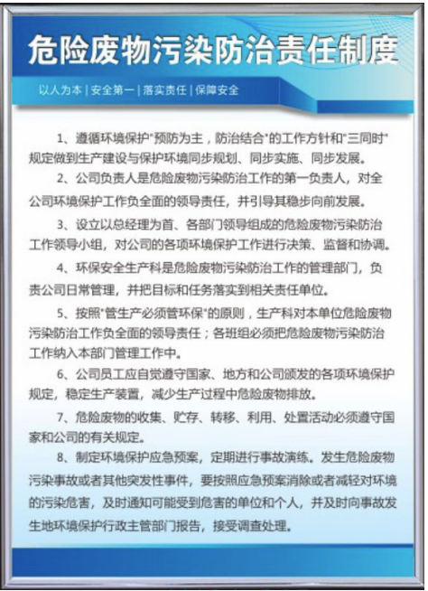

附件2 Attachment 2
危险废物污染防治责任信息公开示例
Example of disclosure of hazardous waste pollution control responsibility information
（出自河北省危险废物规范化环境管理评估工作指南 2023年版）
(From Hebei Province hazardous waste standardized environmental Management assessment work Guide 2023 edition)
